1. Create a directory "exercise" inside your home directory and create a nested(dir1/dir2/dir3) directory structure inside "exercise" with a single command.

Ans : 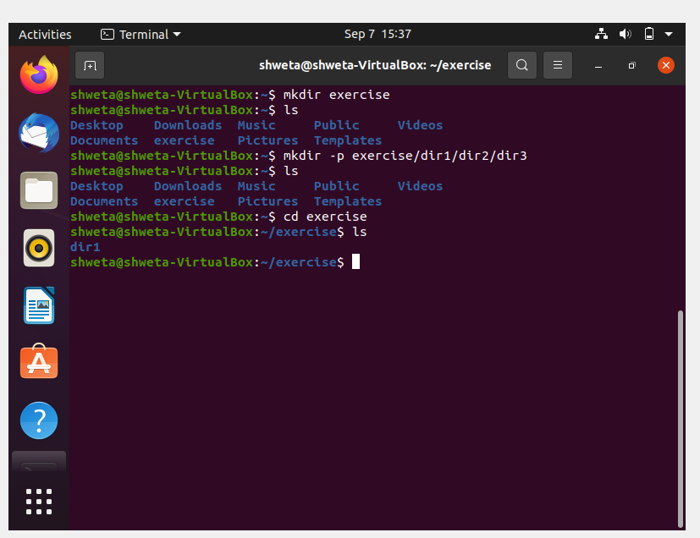

2.Create two empty files inside dir2 directory: emptyFile1,emptyFile2 in single command.

Ans: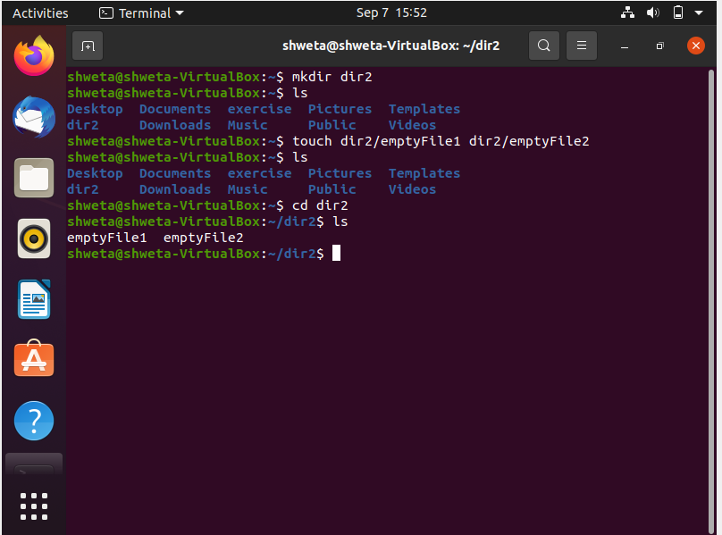

3. Create one file file1.txt containing the text "hello world" and save it.

Ans: 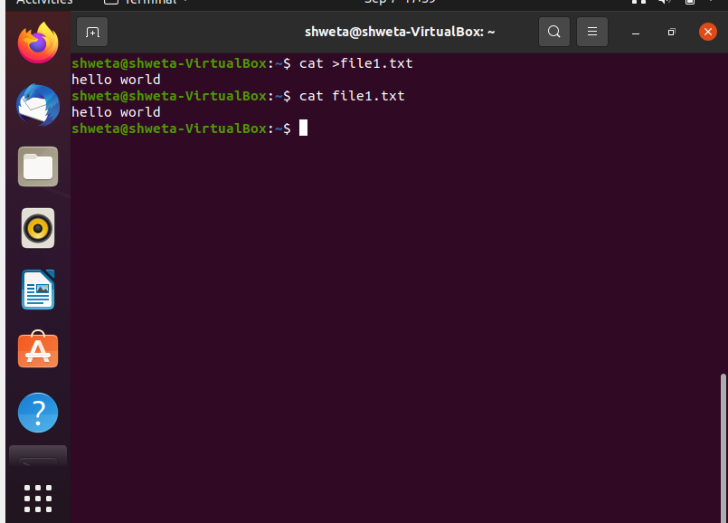

4. Find a "passwd" file using find command inside /etc. copy this file as passwd_copy and then rename this file as passwd_backup.

Ans: 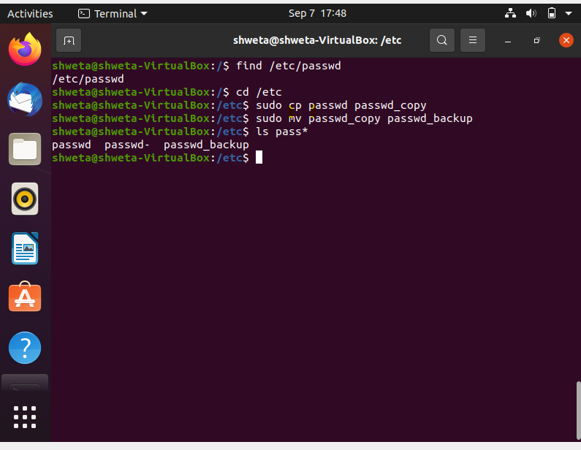

5. Try reading the passwd_backup file in multiple tools: less, more, cat, strings, etc, and find the difference in their usage.

Ans:

* **Less command** is a utility that can be used to read one page or one screen of a file at a time.

command-> less filename

* **More command** is used to view the text files in the command promt, displaying one screen at a time in case the file is large and also allows the user do scroll up and down through pages.

command -> more filename.

* The main difference between more and less command is ,more allows us to view them as a single file separated by lines and less allows us to switch between them.
* **cat command** displays all the content of file at once.

command-> cat filename

* **Strings command** reads text data available in binary file.

command-> strings filename

Less : if file is large it doesn’t access the complete file, but accesses it page by page. It is faster than more command

More : it access complete file.

6. Find out the number of lines in password_backup containing "/bin/false".

Ans:

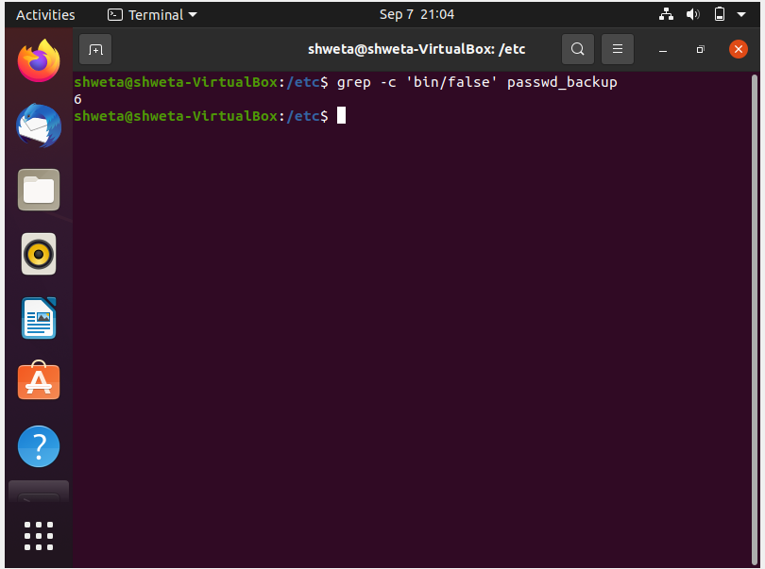

7. Get the first 5 lines of a file “password_backup” and Redirect the output of the above commands into file "output".

Ans: 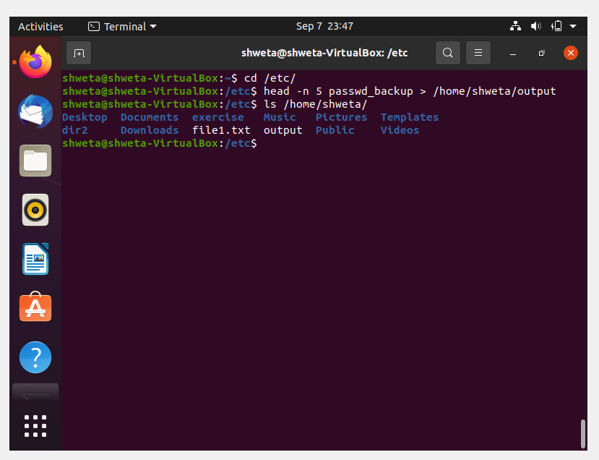

8. Create a "test" user, create its password and find out its uid and gid.

Ans: 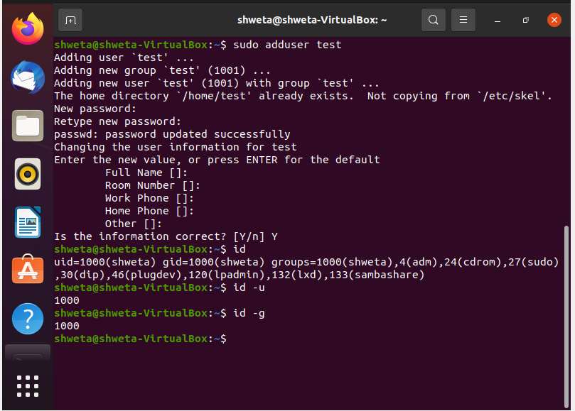

We have to find the uid and gid of test user and you have find out for the “shweta” user.

$ id test

9.Change the timestamp of emptyFile1,emptyFile2 which are exist in dir2.

Ans: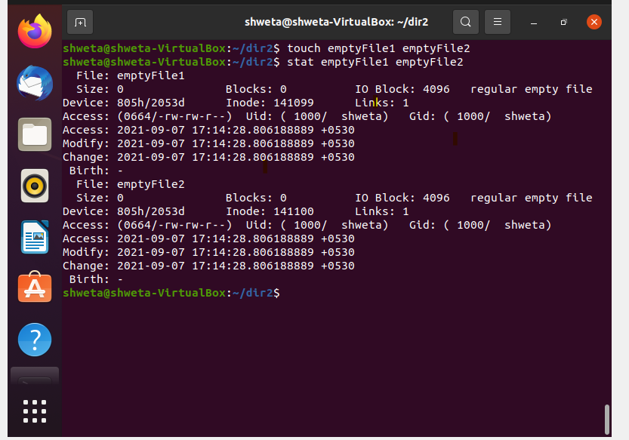

10.Login as test user and edit the "output" file created above. Since the permission wont allow you to save the changes. Configure such that test user can edit it.

1.Add group owner of the "output" file as the secondary group of testuser and check/change the "output" file permission if it is editable by group. Once done revert the changes  
 We have to make a test user as a group owner of output file.

$ chown shweta:test output.txt

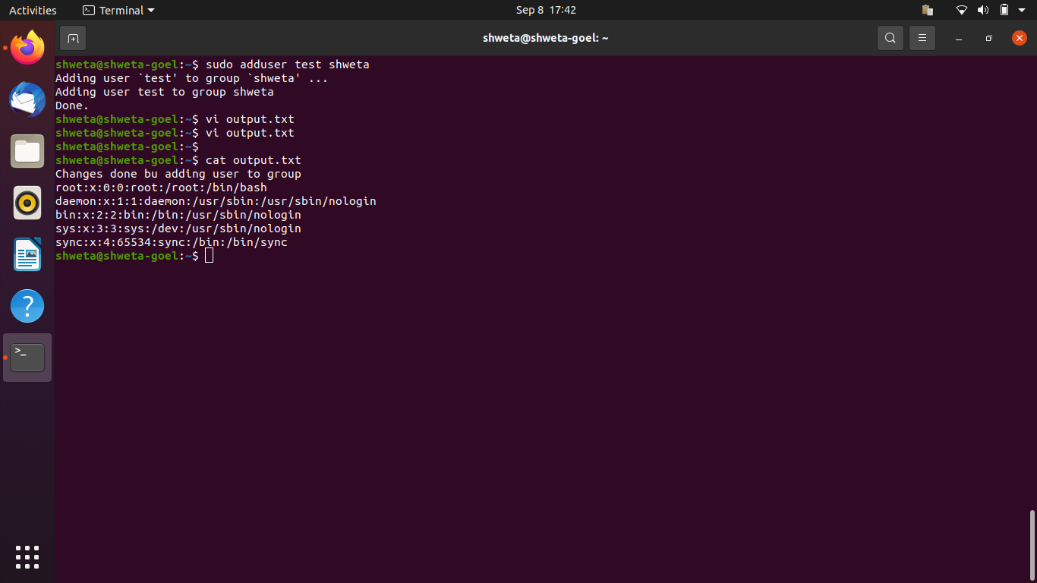

2. Make the file editable to the world so that test user can access it. Revert the changes after verification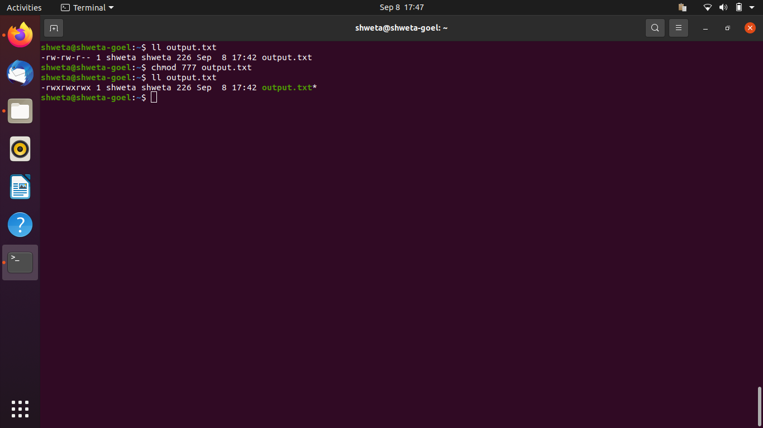

3. Change the ownership to edit the file.

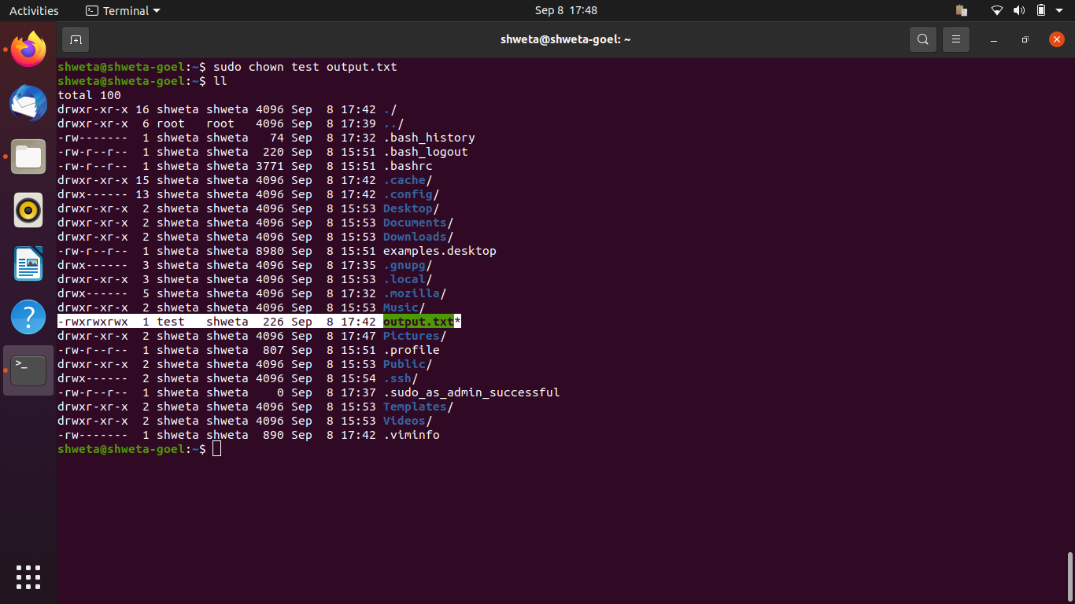

11. Create alias with your name so that it creates a file as "/tmp/aliastesting".

Ans: 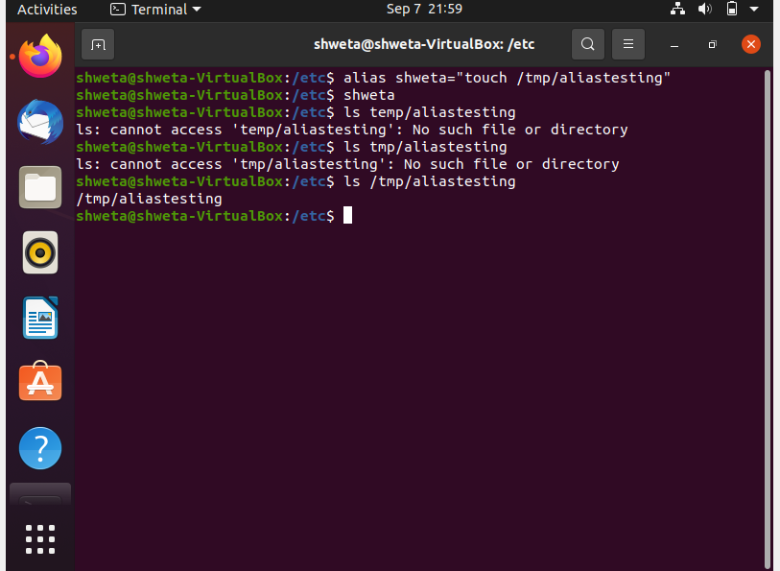

12. Edit ~/.bashrc file such that when you change to "test" user it should clear the screen and print "Welcome".

Ans :

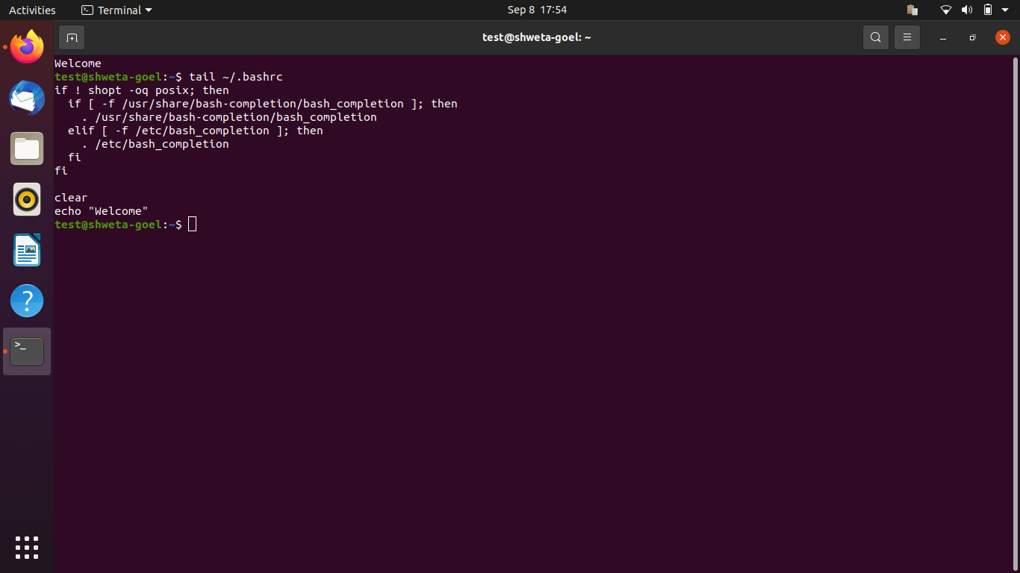

13.Install “zip” package.

Ans: to install -> sudo apt insall zip

For version -> zip -v

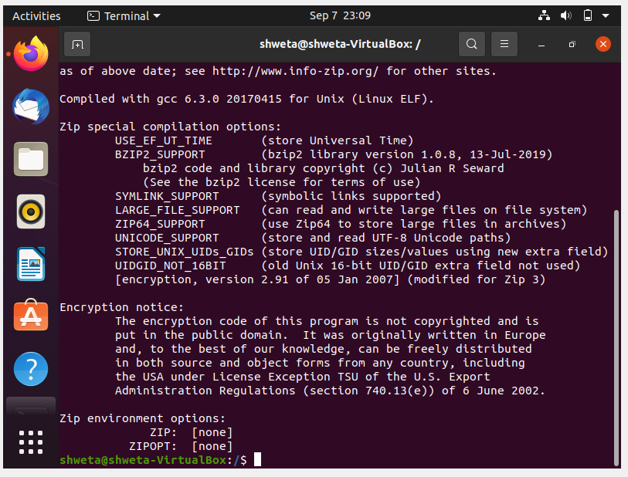

14. Compress "output" and "password_backup" files into a tar ball. List the files present inside the tar created.

Ans: 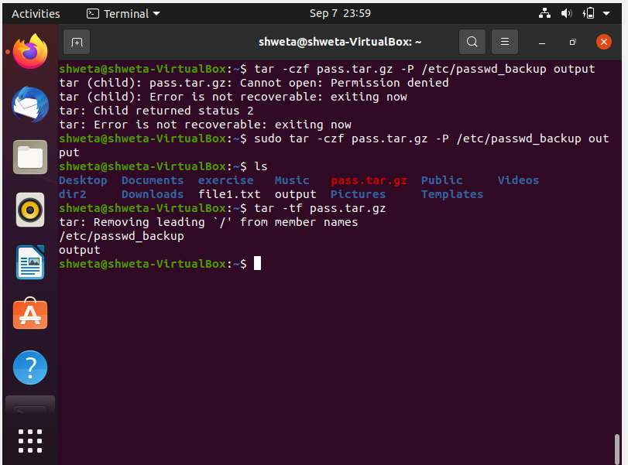

15.scp this file to test user.

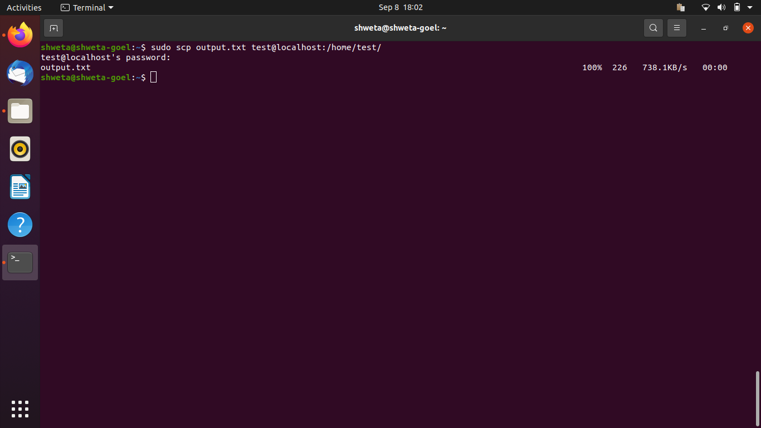

16.Unzip this tar file by logging into the remote server.

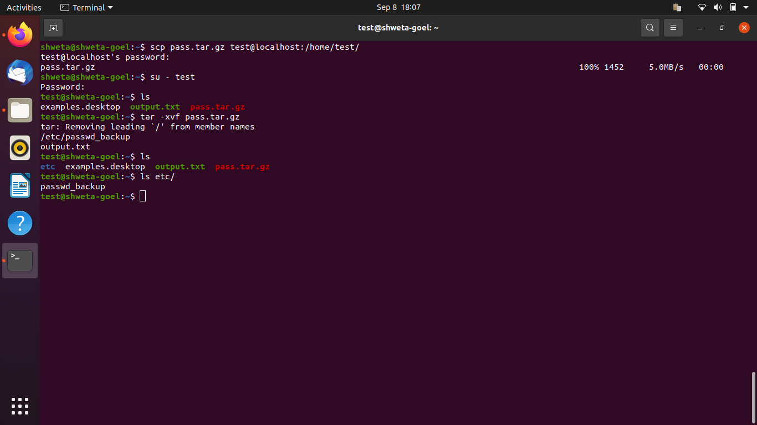

17.Download any image from web and move to desktop

Ans: 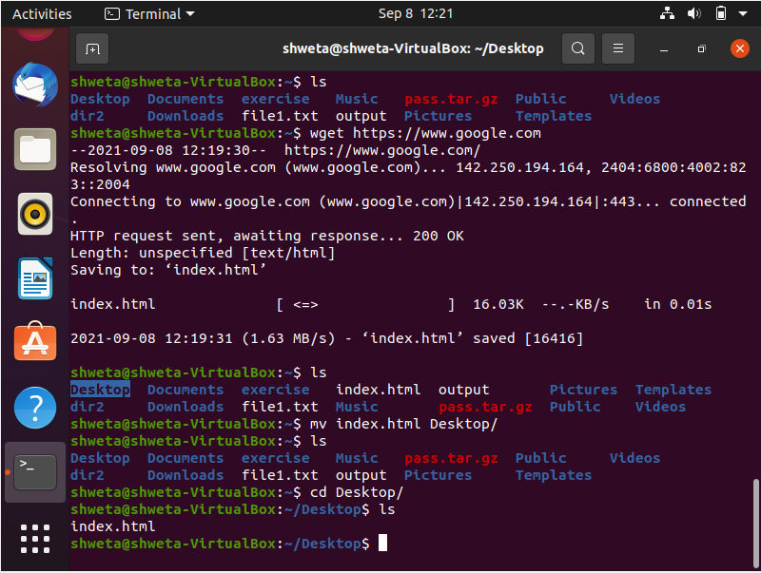

18. How to get help of commands usages.

Ans: 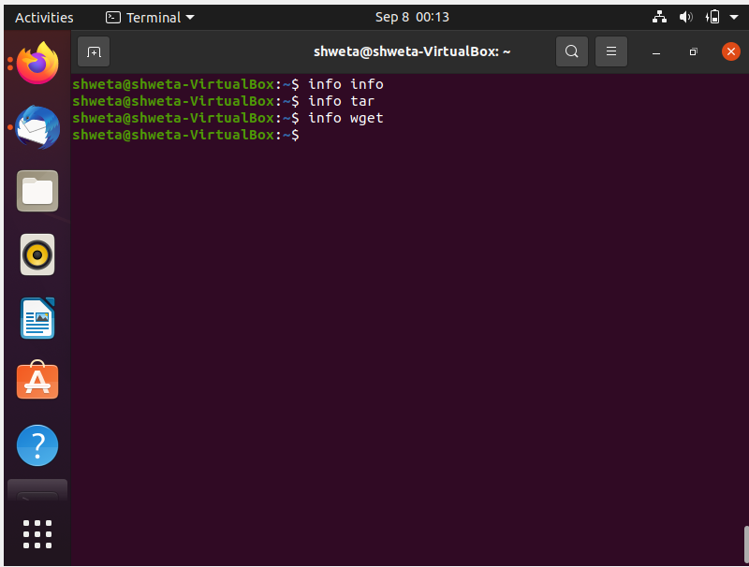

By pressing q, we exit back to terminal.

19.Create a symlink of /etc/services into /tmp/ports-info

Ans: 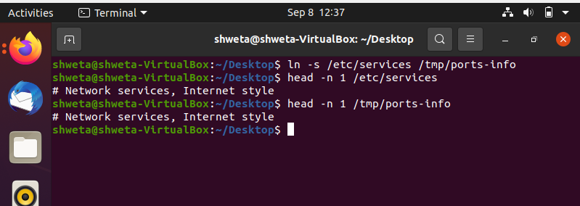

20. You are appointed as a Software/DevOps Engineer in ABC media services. On your first day you need to troubleshoot a problem. There is a command “xyz” somewhere installed in that linux system. But as a new joinee you do not have any idea about where is that Installed. How can you check that?

Ans: 